
RAMAIAH
Institute of Technology
USN | 1 | M | S

(Autonomous Institute, Affiliated to VTU)
(Approved by AICTE, New Delhi & Govt. of Karnataka) Accredited by NBA & NAAC with ‘A’ Grade

MAKEUP EXAMINATIONS – FEBRUARY 2020
Program | : | B.E.: Electrical and Electronics Engineering | Semester | : | V
Course Name | : | Transmission and Distribution | Max. Marks | : | 100
Course Code | : | EE53 | Duration | : | 3 Hrs

Instructions to the Candidates:
- Answer one full question from each unit.

 |  | UNIT- I
1. | a) | With neat diagram, briefly explain the following with respect to HVDC transmission:  i) Monopolar DC link ii) Bipolar DC link iii) Homopolar DC link. | CO1 | (09)
 | b) | What do mean by sag in an over head line? Discuss the disadvantages of too small or too large sag on a line. | CO2 | (05)
 | c) | An overhead transmission line has a span of 250m, the conductor weighing 700 kg/km. Calculate the maximum sag if the breaking stress is 4485 kg/cm² while the area of the conductor is 1.19 cm². Assume factor of safety = 2. | CO2 | (06)
2. | a) | What are the factors considered for the choice of the conductor materials for overhead lines? | CO2 | (05)
 | b) | What are the various types of line supports? Discuss the suitability of each with reference to system voltage and span. | CO2 | (07)
 | c) | The line supports of an overhead line are 180 m apart and are at the same level. The line conductor is of hard drawn copper having a diameter of 1.27 cm. Calculate the maximum sag  i) in still air and  ii) in a wind pressure of 33.7 kg per square metre of the projected area of the ice covered line. The radial thickness of the ice is 1.25 cm.  Assume that the maximum stress in the line is not to increase one fifth of the ultimate strength of 4220 kg per cm². The weight of conductor per metre run is 1.13 kg. | CO2 | (08)
 |  | UNIT- II
3. | a) | What do you mean by transposition of line conductors and why transposition of conductors in a three phase transmission lines is essential? | CO3 | (05)
 | b) | Define GMD and GMR. Explain the role of GMD and GMR in line inductance calculation. | CO3 | (05)
 | c) | Two conductors of a single phase line, each of 1 cm diameter are arranged in a vertical plane with one conductor mounted 1 m above the other. A second identical line is mounted at the same height as the first and spaced horizontally 0.25 m apart from it. The two upper and the two lower conductors are connected in parallel. Determine the inductance per km of the resulting double circuit line. | CO3 | (10)
4. | a) | Derive an expression for the capacitance of a 3 phase unsymmetrical but regularly transposed line. | CO3 | (08)
 | b) | Write a note on standard and bundled conductors. | CO3 | (06)
 | c) | A single phase overhead line 30 km long consist of two parallel wires each 5 mm in diameter and 1.5 m apart. If the line voltage be 50 kV at 50 Hz, calculate the charging current with the line open circuited. | CO3 | (06)
 |  | UNIT- III
5. | a) | With the help of a phasor diagram illustrating Ferranti effect, explain Ferranti effect and also derive an expression for power loss in an open circuited line. | CO4 | (10)
 | b) | A 3 phase transmission line is 400 km long and caters a load of 450 MVA, 0.8 p.f. lag at 345 kV. The ABCD constants are  A = D = 0.8181 ∠ 1.3⁰ B = 172.2 ∠ 84.2⁰ C = 1.933 x 10⁻³ ∠90.4⁰ mho. Calculate sending end current and percentage voltage drop. Also calculate receiving end line to neutral voltage at no load and the sending end line to neutral voltage. | CO4 | (10)
6. | a) | Evaluate the generalized circuit constant for medium transmission line using:  i) nominal T method ii) Nominal π method. | CO4 | (10)
 | b) | A 220kV, 3-phase transmission line is 40km long. The resistance per phase is 0.15Ω per km and the inductance per phase is 1.5923 mH per km. The line is supplying a 3-phase load of 381 MVA at 0.8 pf lagging. Find: (i) the voltage and power factor at the sending end of the line (ii) the voltage regulation and efficiency of the line. | CO4 | (10)
 |  | UNIT- IV
7. | a) | Explain, with a neat sketches, the constructional features of pin type and suspension type insulators. List the advantages of the latter type over the former, for high voltage transmission lines. | CO5 | (08)
 | b) | A single core cable employing three layers of insulation with dielectric constants ε_{r1} = 5, ε_{r2} = 4 and ε_{r3} = 3 respectively has a conductor of radius 1cm. Assuming that all the three insulating materials are worked at the same maximum potential gradient, workout the potential difference in kV between the core and earthed sheath. The inner radius of the sheath is 2.5cm and the maximum potential gradient is 40kV/cm. | CO5 | (06)
 | c) | With a neat sketch explain the general construction of the cable. What are the necessary requirement of a cable. | CO5 | (06)
8. | a) | Compare the performance of cables using:  i) Capacitance grading ii) Intersheath grading. | CO5 | (08)
 | b) | Each of the three insulators forming a string has a self capacitance of C farads. The shunting capacitance between earth and metal work of each insulator is 0.18 C while it is 0.1 C between metal work and line. Calculate the voltage across each insulator as a percentage of the line conductor voltage to earth and the string efficiency.  Now a guard ring is provided, increasing the capacitance to the line of the metal work of the lowest unit to 0.25 C. Calculate the new string efficiency and redistribution of the voltage. | CO5 | (12)
 |  | UNIT- V
9. | a) | Explain different types of distribution systems with the help of neat sketches. | CO1 | (06)
 | b) | With neat diagram, explain DC distributor fed form both ends with unequal voltages. | CO1 | (06)
 | c) | A dc distributor cable shown in Fig. 9(c) is 1000m long and is loaded as under:  The resistance of each conductor is 0.025 Ω per 1000m. Find the voltage at each load point if the voltage at the feeding point A is maintained at 250V.  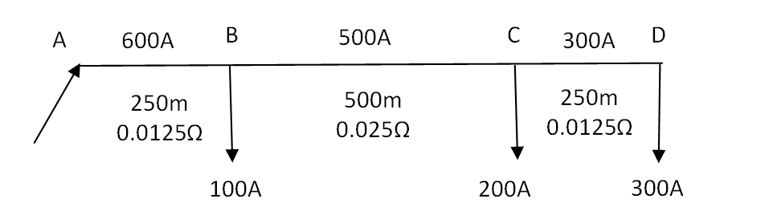  Fig. 9(c) | CO1 | (08)
  Distance from the feeding point (metres) “A” | 250 | 750 | 1000
  Load in amperes | 100 | 200 | 300
10. | a) | With the help of phasor diagram, discuss the AC distribution when power factors referred to receiving-end voltage. | CO1 | (06)
 | b) | How AC distribution differs from DC distribution? Discuss. | CO1 | (04)
 | c) | A single phase two-wire feeder shown in Fig.10(c) is 1500 m long, supplies a load of 60A at 0.8pf; 40A at 0.85pf; and 50A at 0.88 pf lagging at distances of 600m, 1200m and 1500m respectively from the feeding point. The resistance and reactance of the feeder per km length are 0.06 and 0.1 ohms, respectively. If the voltage at the far end is to be maintained at 220V, calculate the voltage at the sending end, and its phase angle with respect to the receiving end voltage.  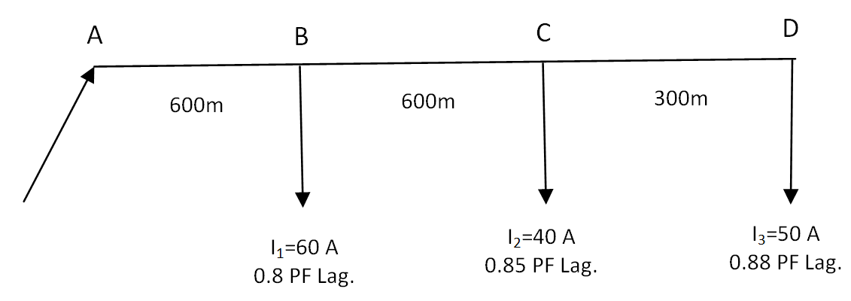  Fig. 10(c) | CO1 | (10)

****************

